Session-3

OLAP VS OLTP:

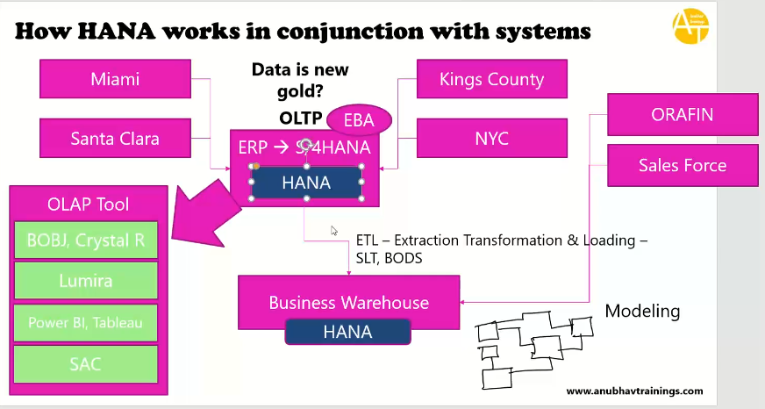

* Company implemented ERP system, that is old system as ORACLE DB, this is current DB of ECC system.
* Ex: walmart has 4 stores , all stores are integrated with ERP-ORACLE(DB)
* Here ERP system meant for day to day transactions.--> is called as OLTP system.(Online transaction processing system ).
* OLTP right optimize system to write data into the system, it writes very fast.
* Data is distributed for a company broadly in multiple system and also may be till today you can’t keep the data in one place because system is right optimized.
* Business warehouse: is the system, to keep the data in long time and to analyze the data later point of time.

BW system is massively optimized system.

BW system using HANA, how do we move data ERP to other systems, through the ETL-Extraction Transformation and Loading.

ETL Tools: BODS/SLT 🡪 Uploading to multiple tables.

* To analyze the models we will use the OLAP tools(Online Analytical Processing), are used for build the analytical purpose such as chart….

SAC- SAP Analytical Cloud.

* Now wal mart replaced with HANA in place of Oracle.
* Suppose company using HANA, then HANA system will do both analytics and transactional processing , get the real time data while using HANA system. (S4 HANA)

EBA- Embeded analytical tool has given by SAP.

* HANA is also called hybrid Data base, means it supports OLAP and OLTP in same box(S4HANA) .

Role of ABAP hana Consultant:

00:00 to 31:00 for introduction to roles individual job

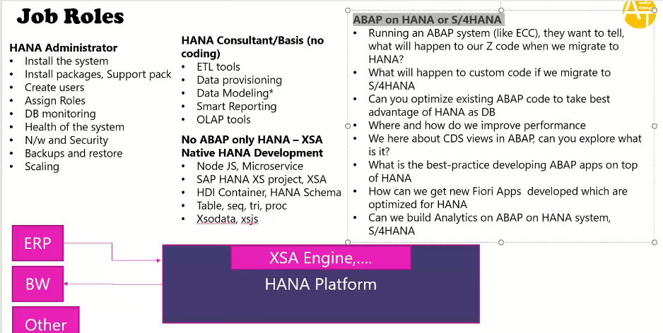

SAP BASIS VERSION-755(Latest) , minimum version is 740- SP level-6 it is very good.

S4HANA- S4CORE( it is S4 hana system)- S4CORE- 105 latest

DATABASE Version:HDB

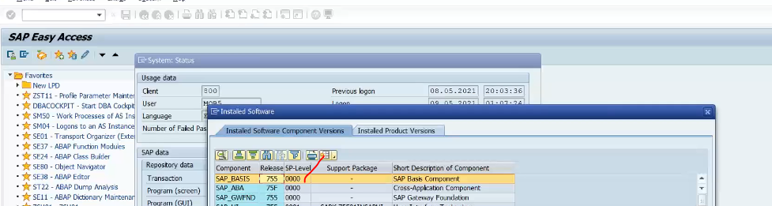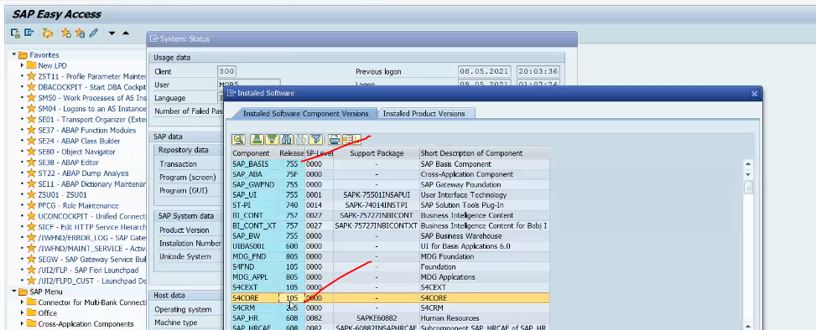 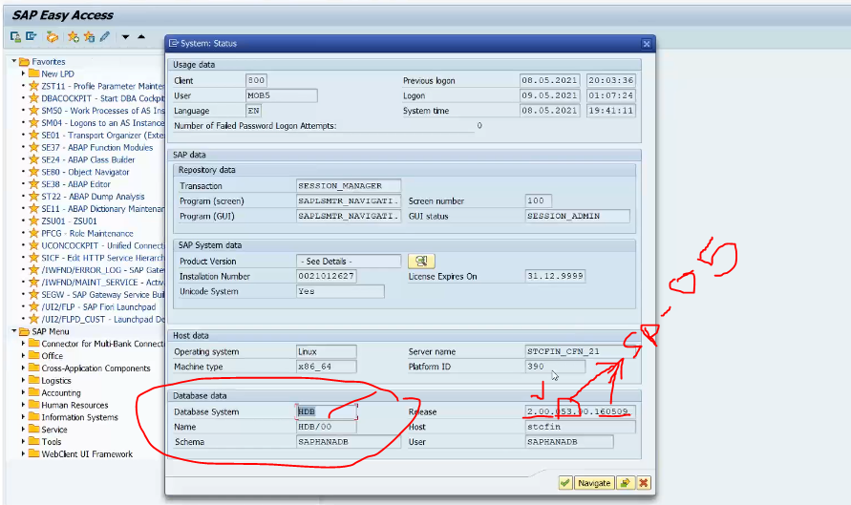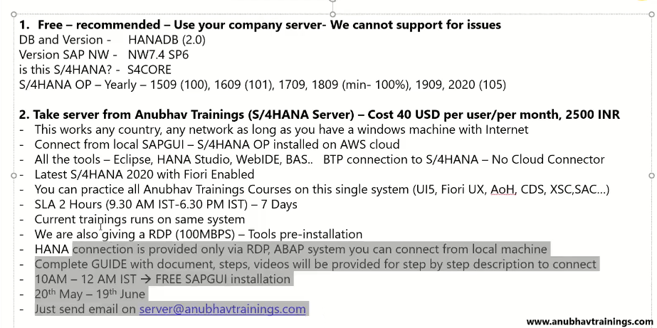.

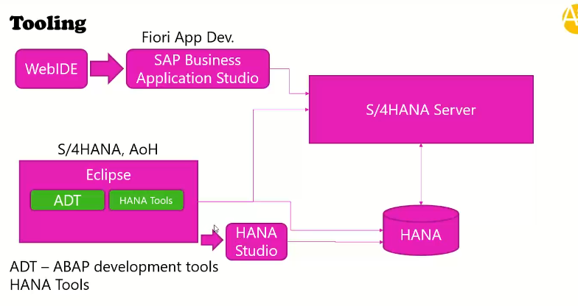

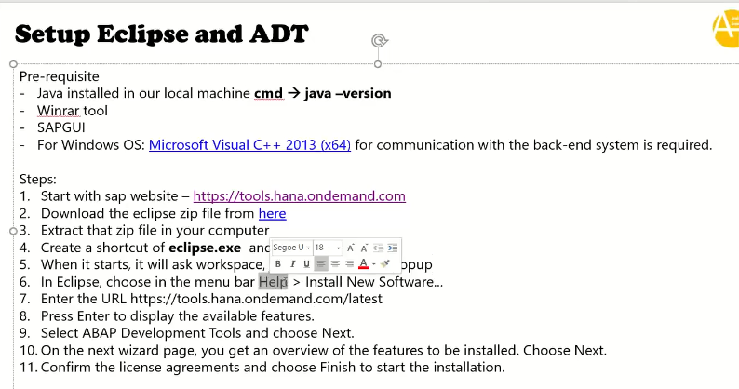

To open the prospective:

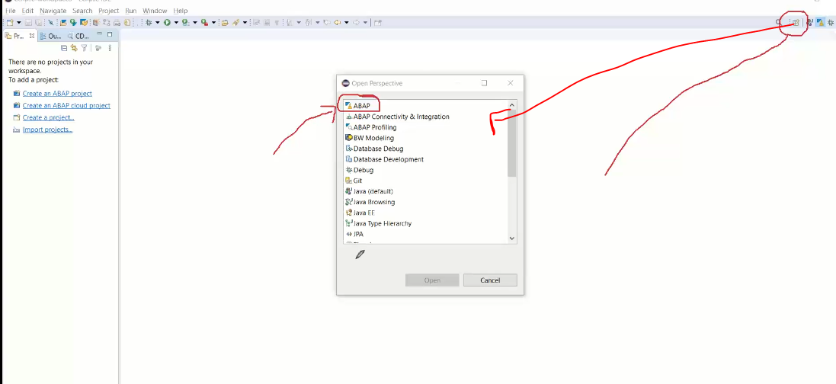

Creating ABAP project: - it is connecting to SAP ABAP system.

If you have 5 systems, how many projects you will create project in ECLIPSE.--> 5 connections.

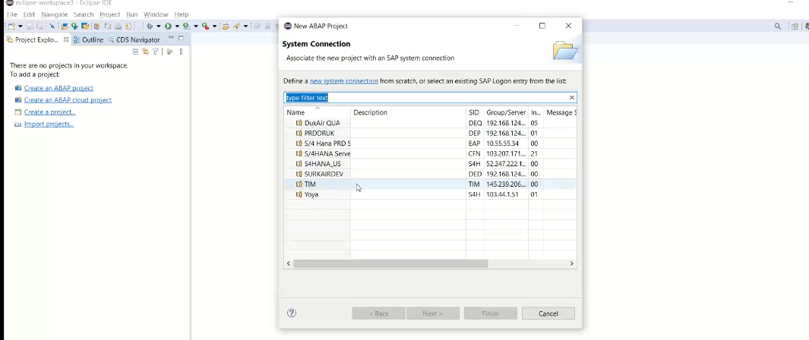

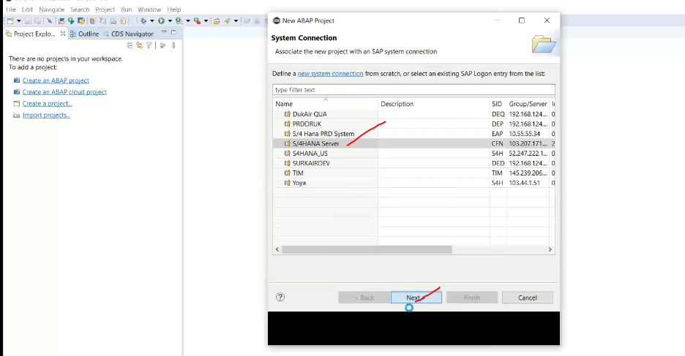

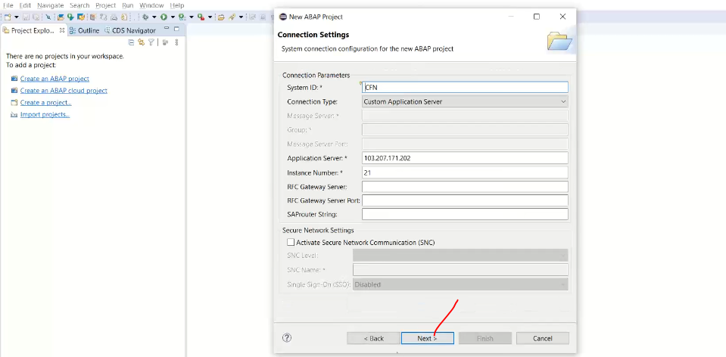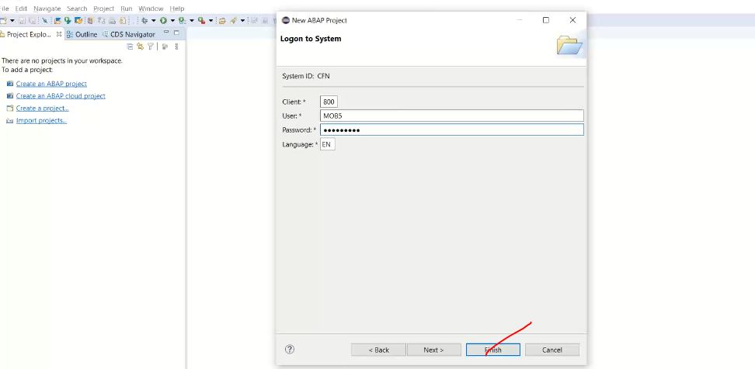

Now system has added in Eclipse.

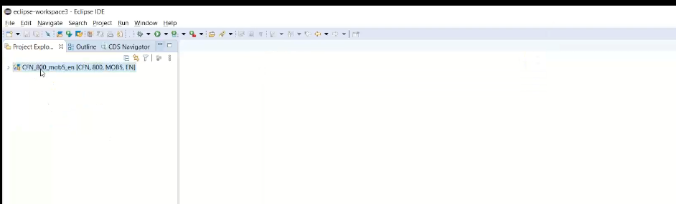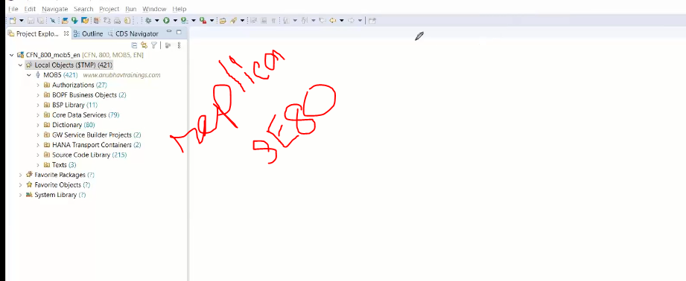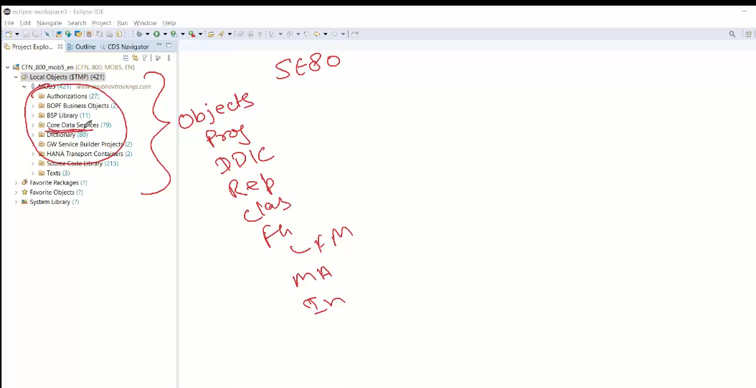

No limit of sessions in eclipse.CTRL+6 enter. 🡪 open new sessions.

CTRL+T 🡪ABAP type hierarchy

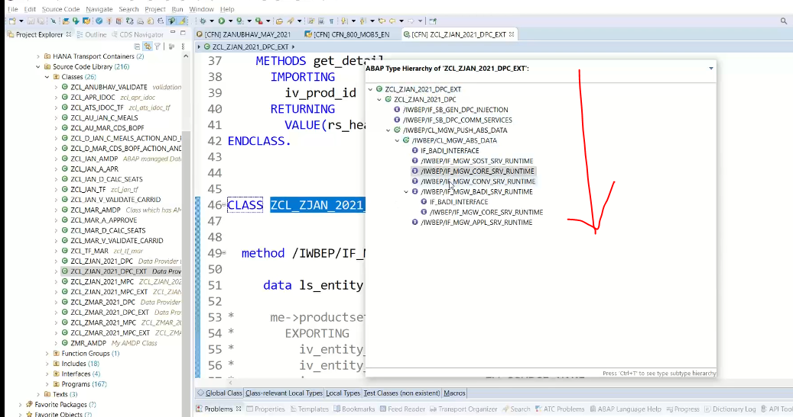

Can’t create CDS Views in SAP GUI.

TRANSPORT Organizer: To create new tr/release tr/add use to the TR/change owner 🡪 like sm01.

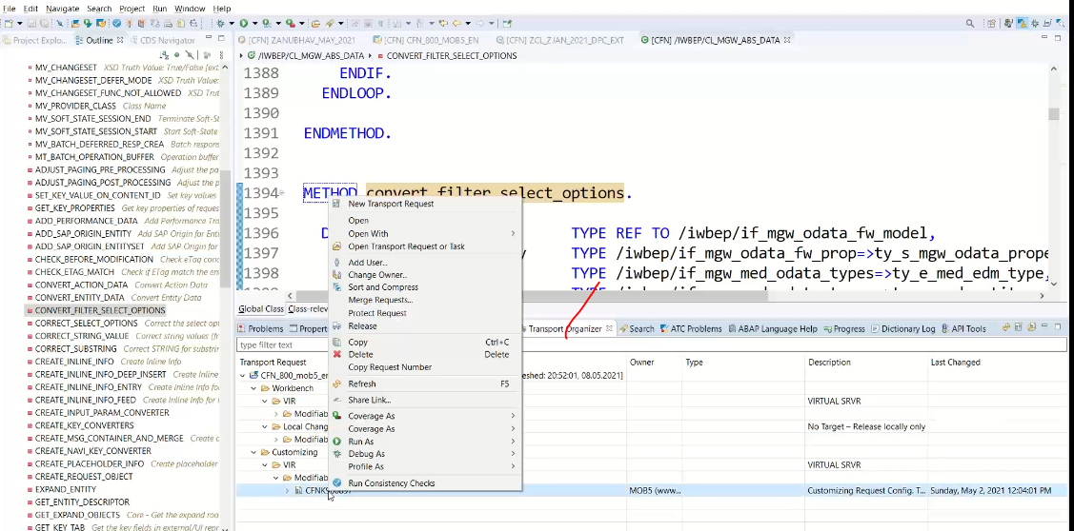

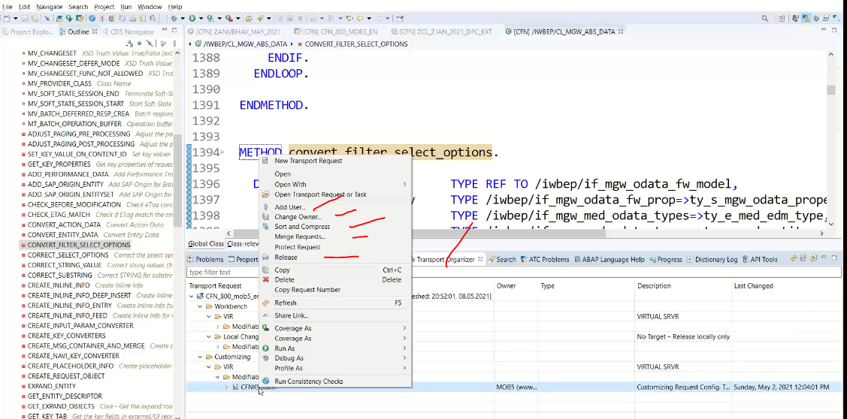

ATC: ABAP Test Cockpit – we will see in next chapters.

Debug:

It is switching abap prospective to debug prospective.

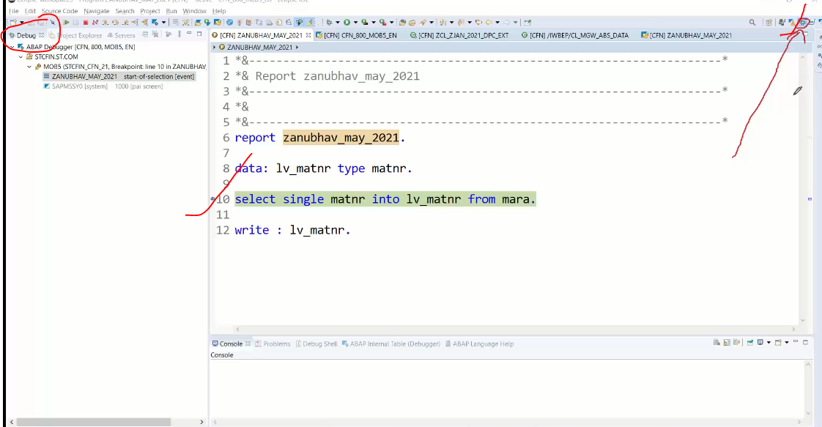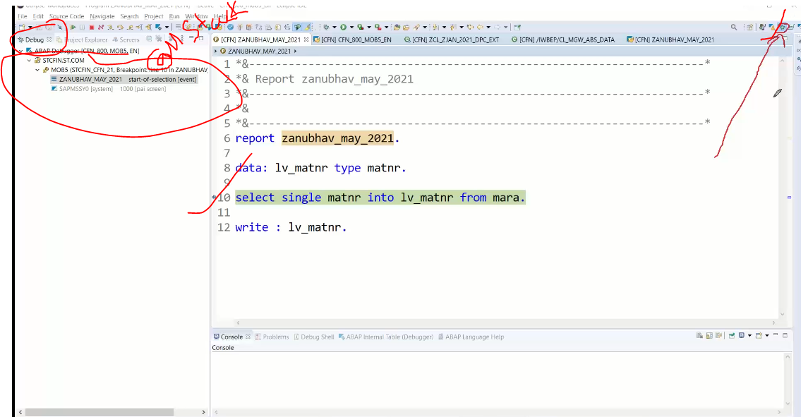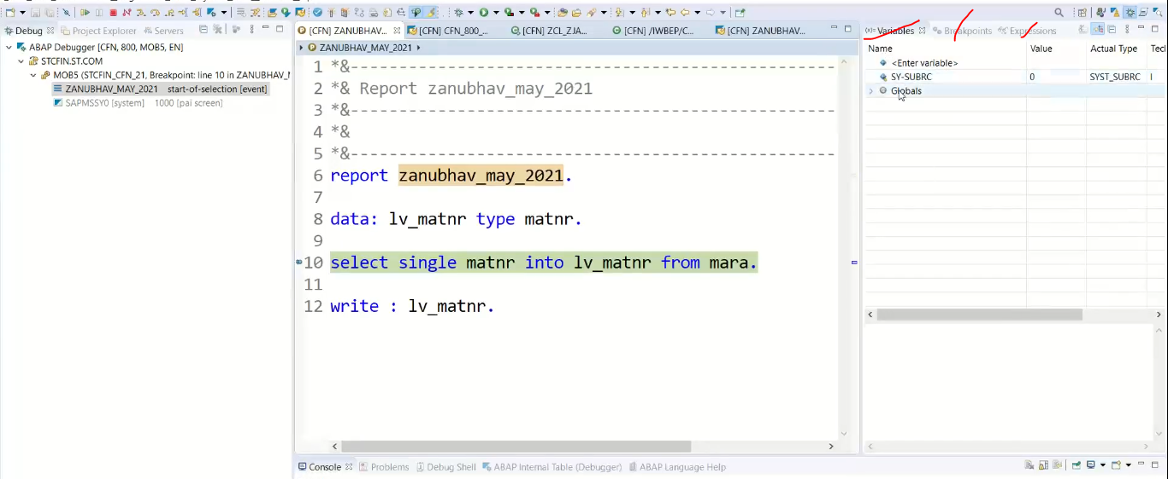

ABAP profiles: give you check on runtime, runtime analysis of program doing.

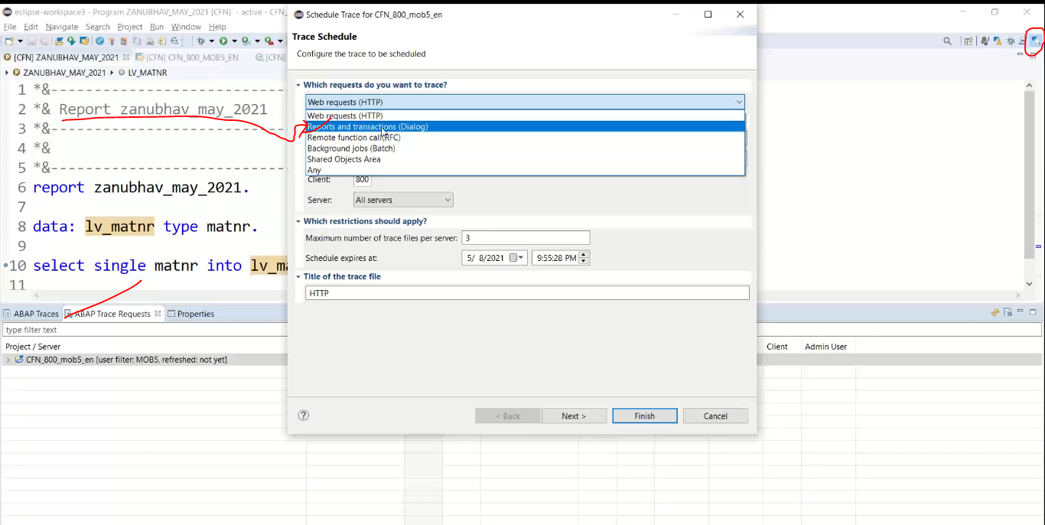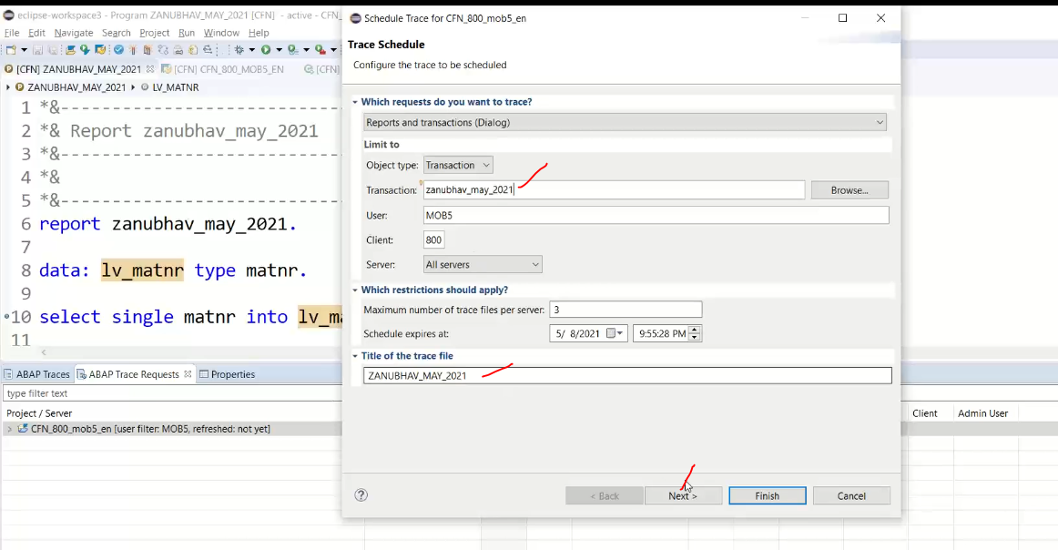

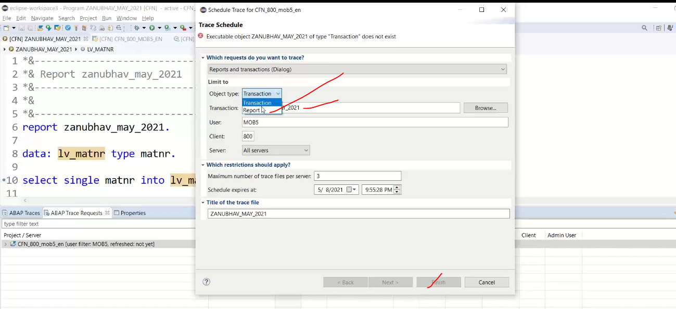

ABAP profiler

Create trace request: for run time analysis.

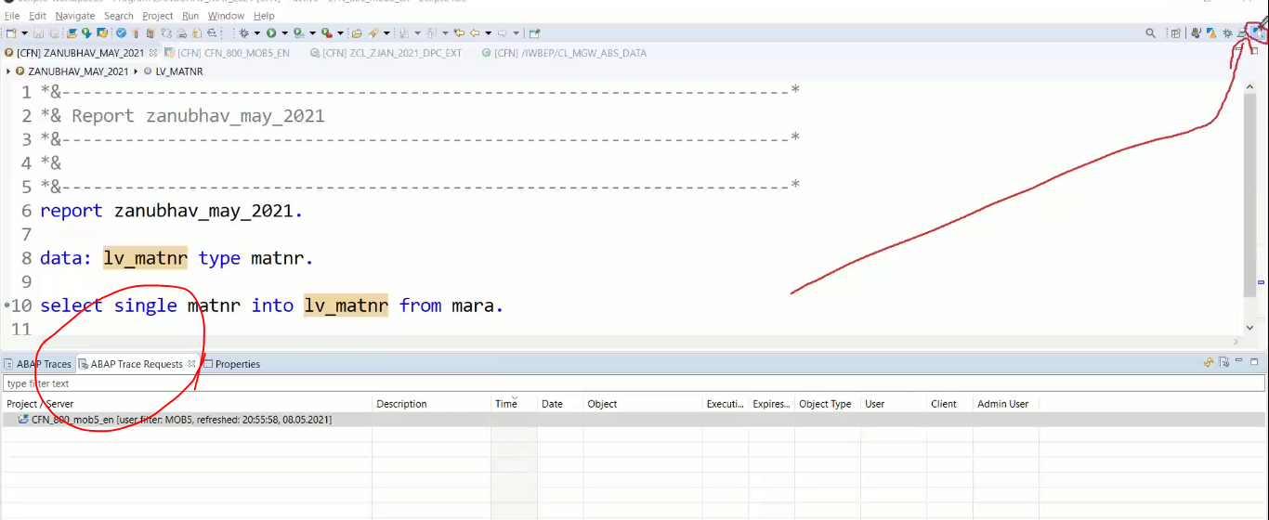

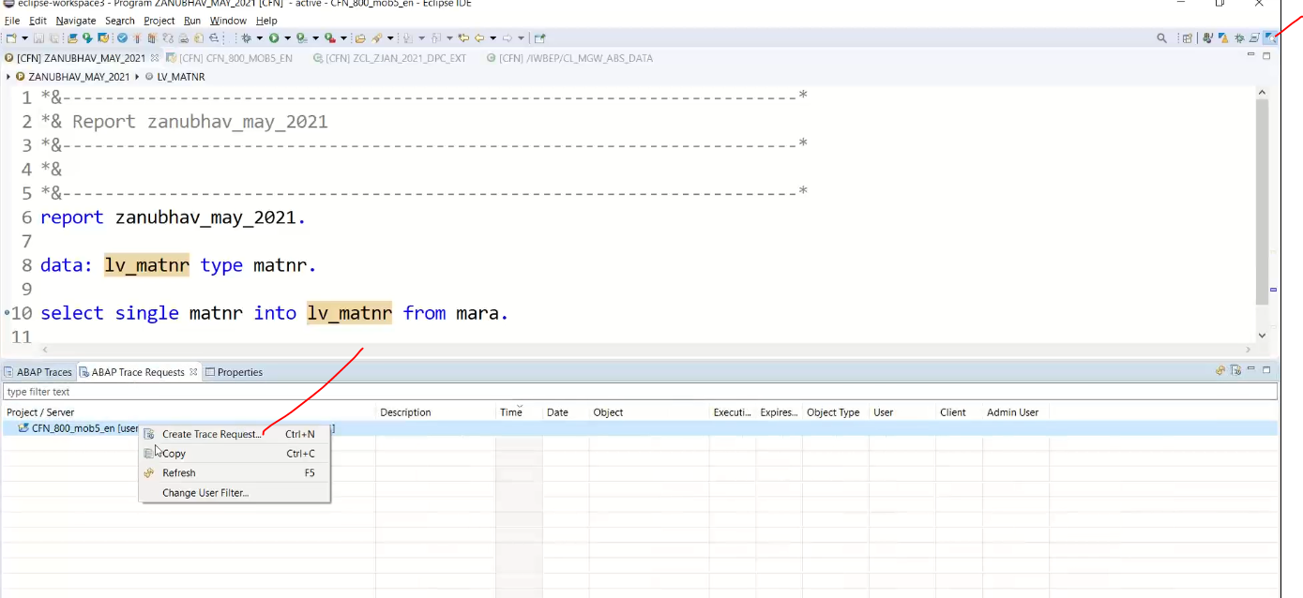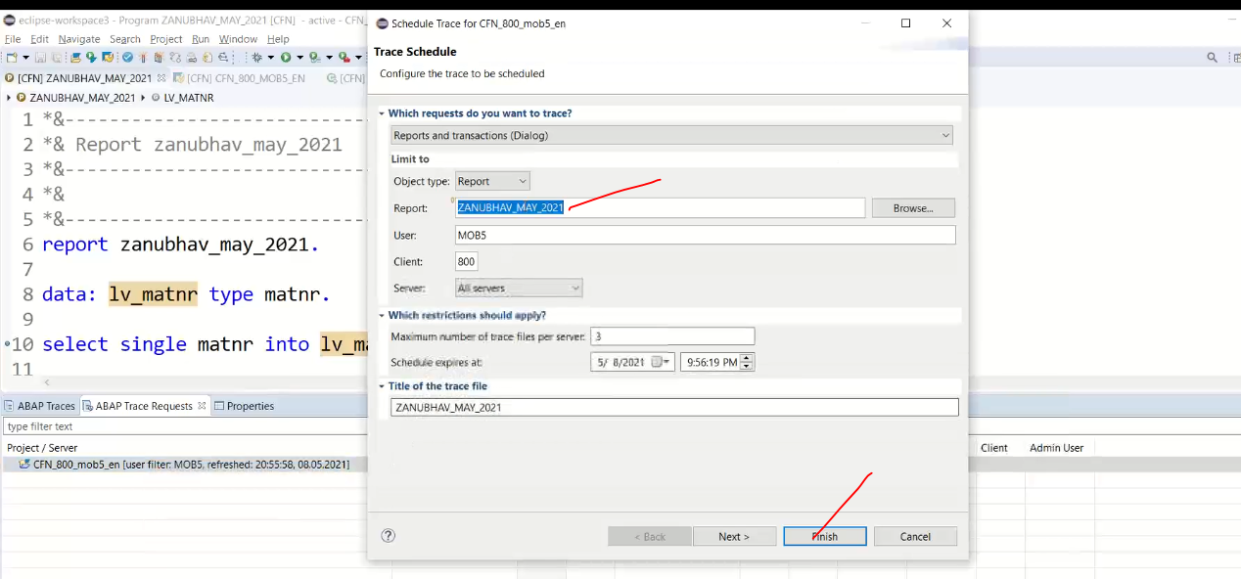

Click on next:

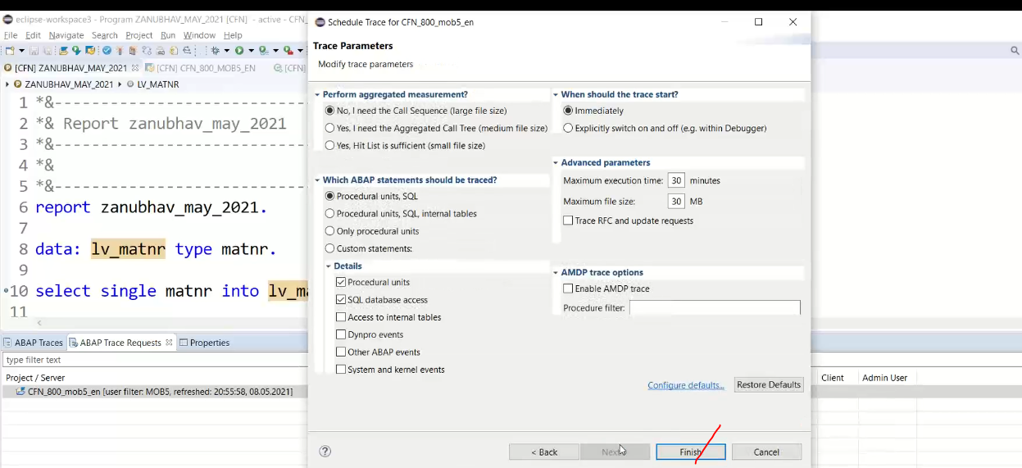

Analyze the trace results in the list.

Like ST05/RUNTIME ANALYSIS

Feed reader: used for dumps/runtime error. Any dump you will get the notifications using the feeder.

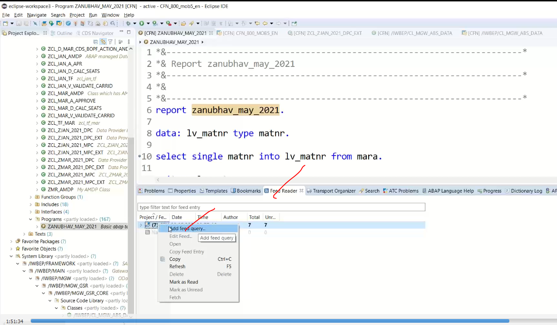

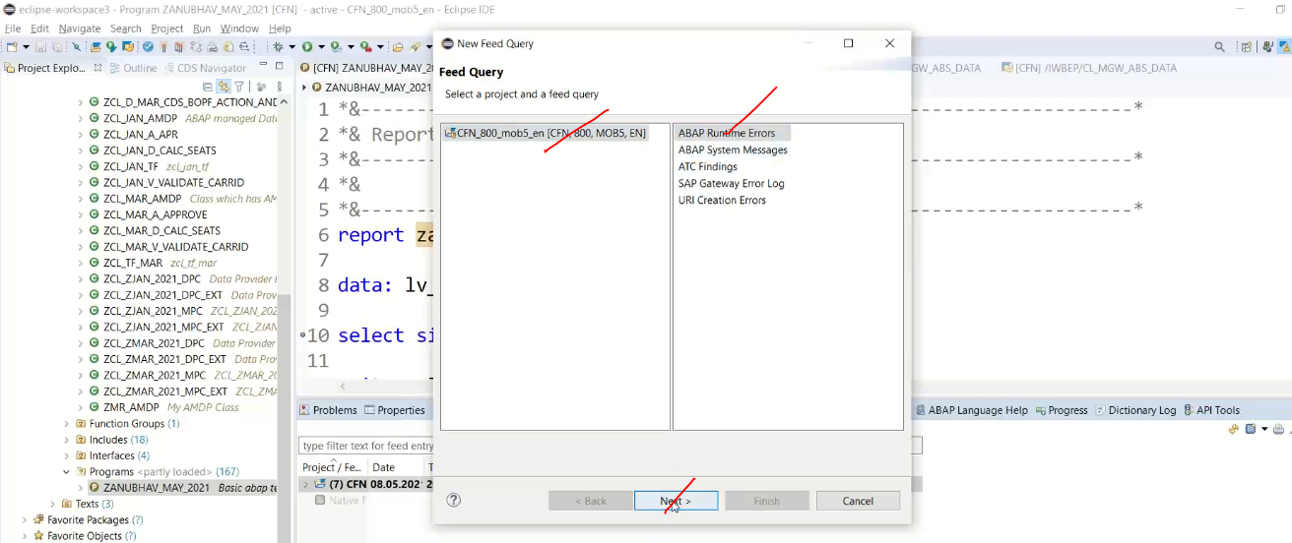

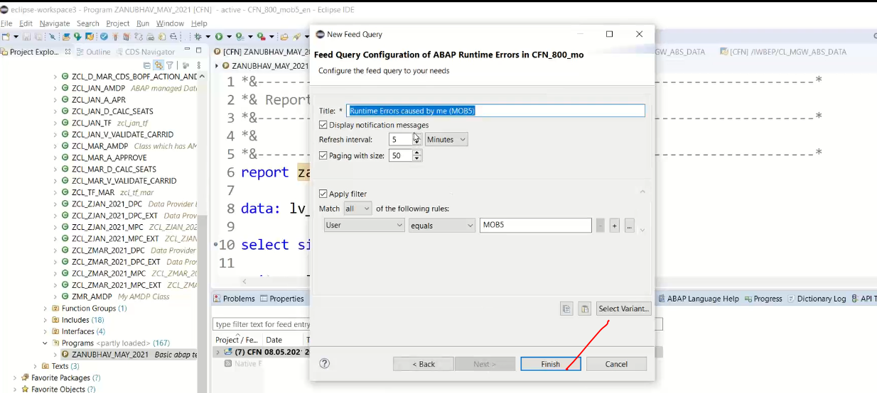

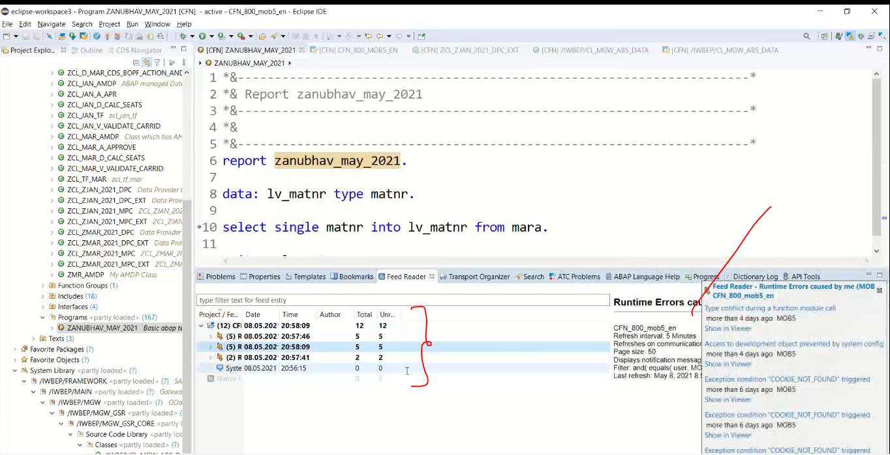

Direct error getting while writing code .--> syntax errors

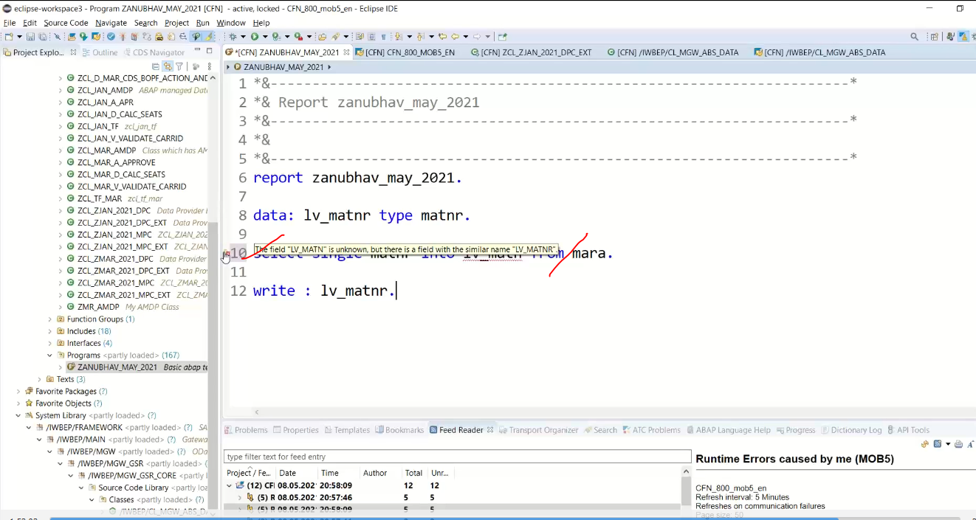

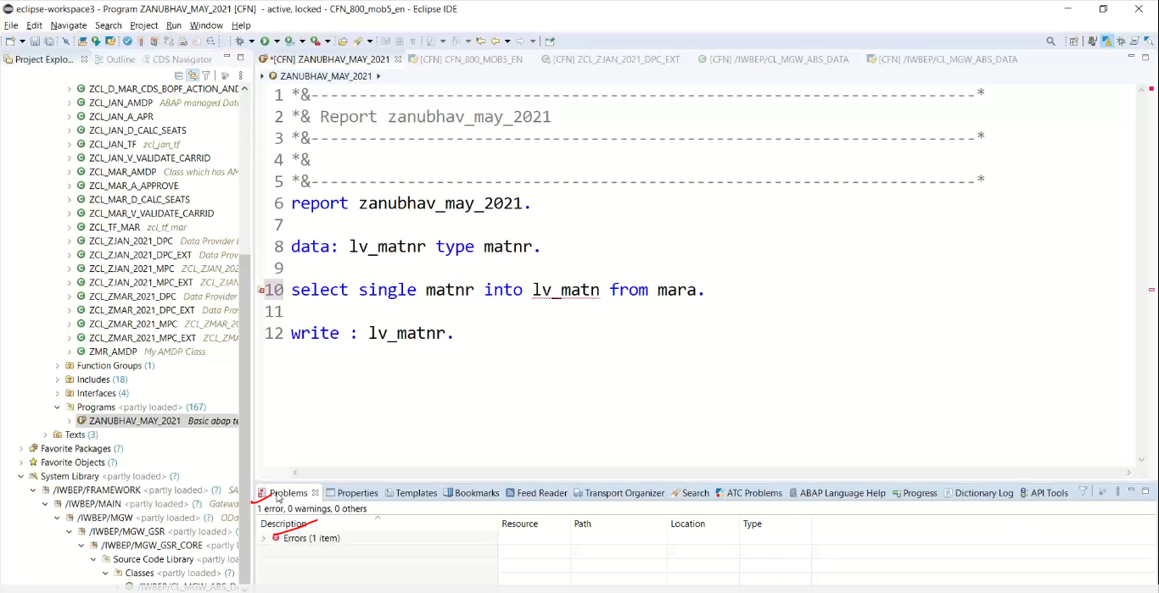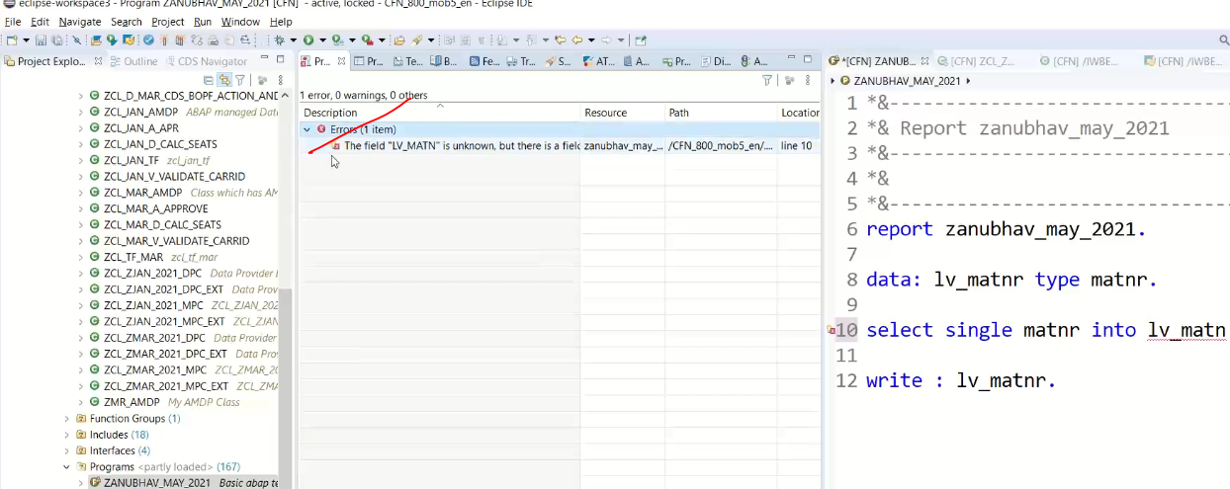

ABAP Templates :

Window 🡪 preferences

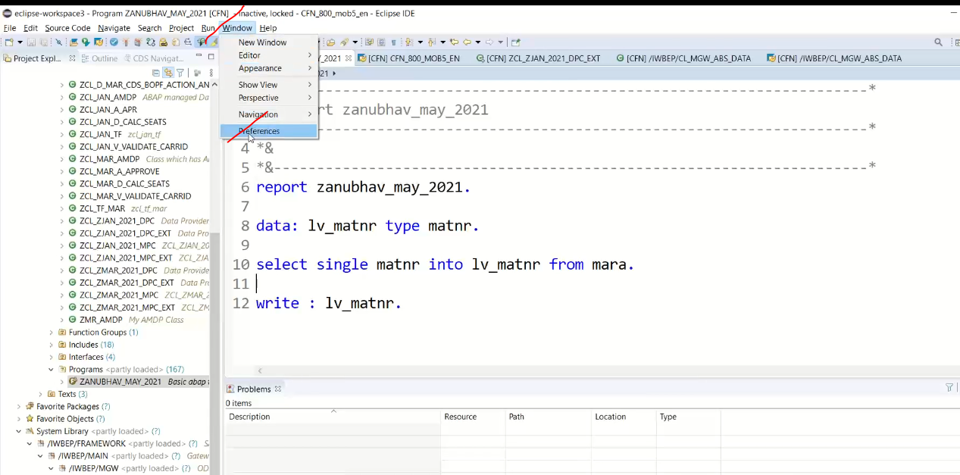

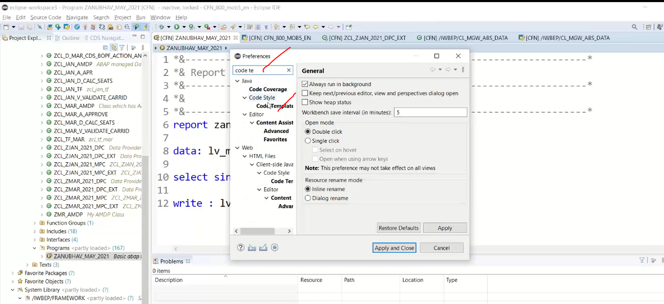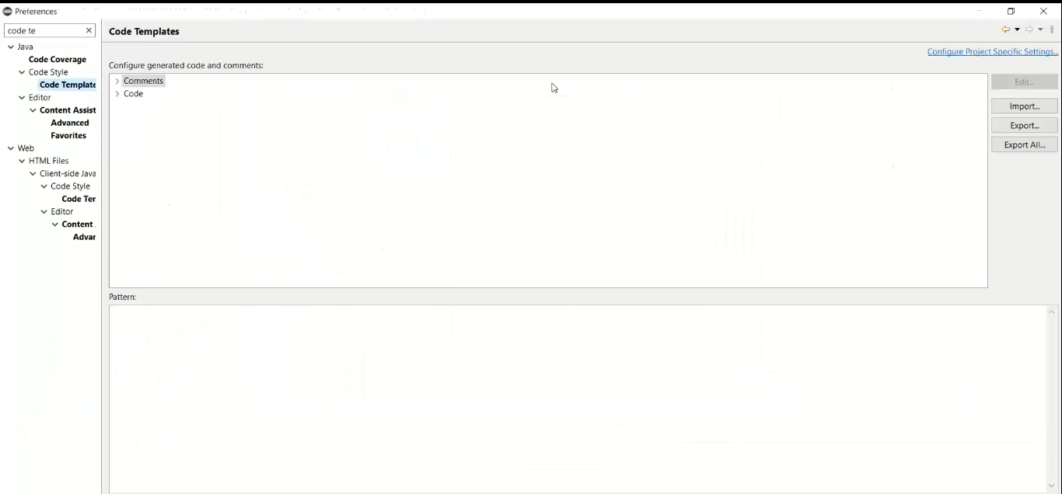

Go to 🡪Abap templates

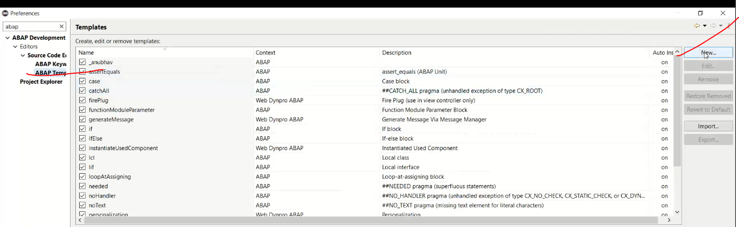

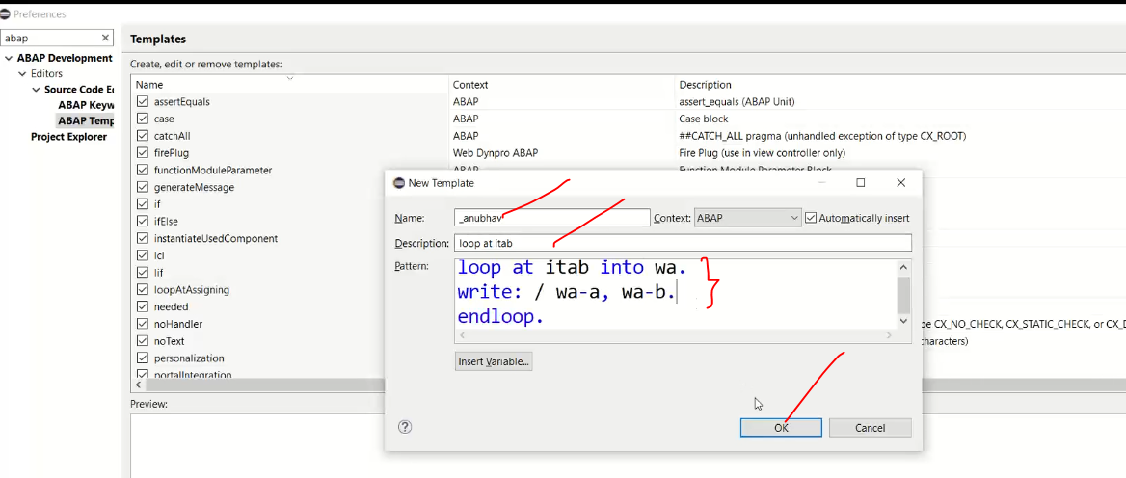

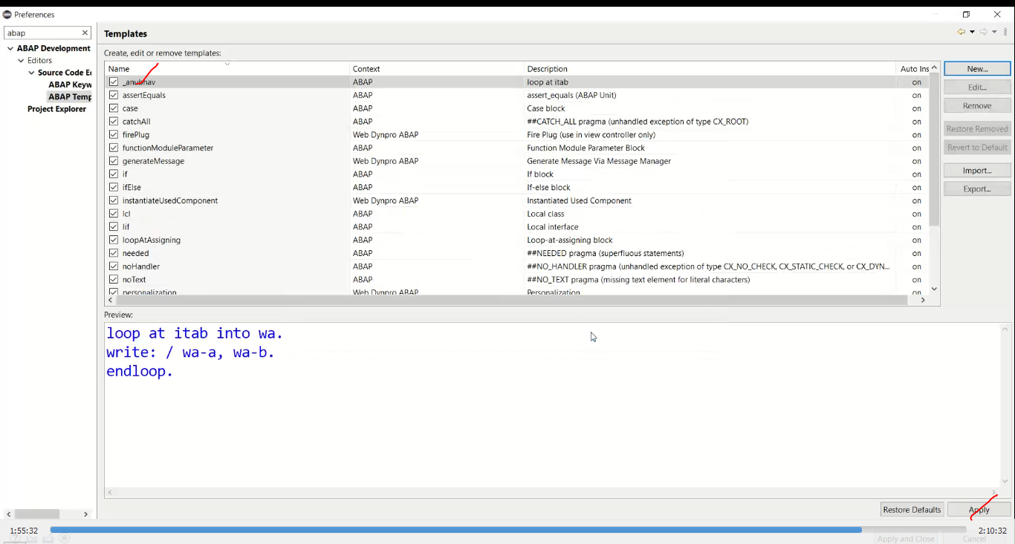

Use the template in your code

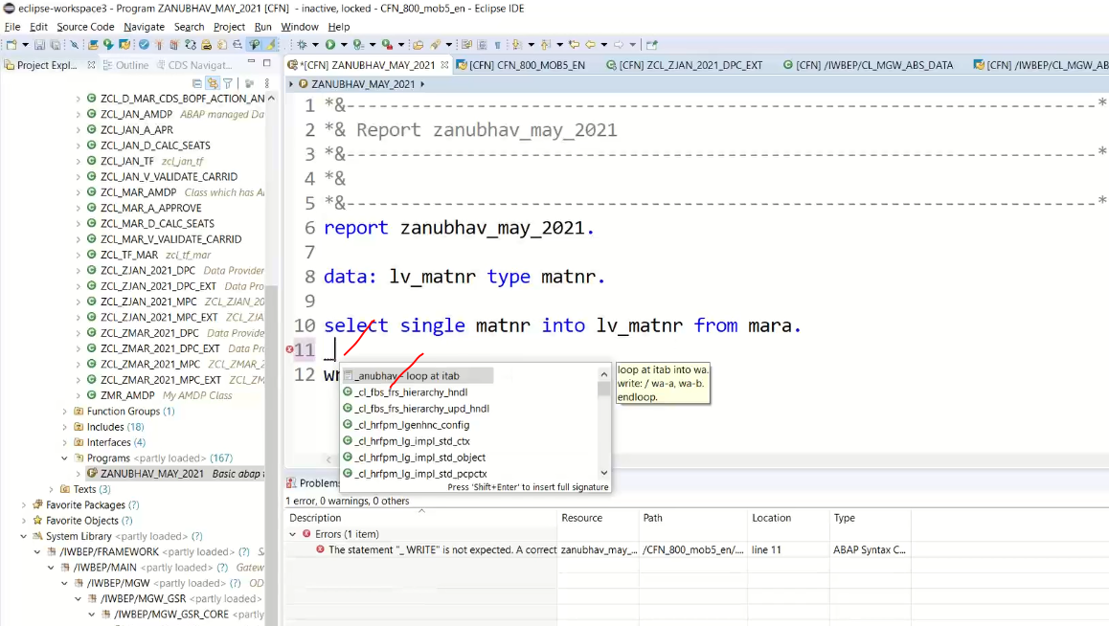

Loop at code generated.

